W-17
YEAR 10 SCIENCE (GENERAL)
PHYSICAL SCIENCE
TOPIC TEST
Name: Mark: 

Part 1: Multiple Choice
MULTIPLE CHOICE ANSWERS
1
2
3
4
5
6
7
8
9
10
11
12
13
14
15
16
17
18
Write your choice for each question in the table below.

1. The crumple zone of a car is designed to:

(a) allow the vehicle and passengers to stop more slowly.
(b) decrease the time before the car comes to a stop after a collision.
(c) allow the chassis to bend.
(d) create a reaction force that equals the action force.

2. How long would a car travelling at a speed of 20 m/s take to cover a
distance of 360 m?

(a) 13 s
(b) 26 s
(c) 18 s
(d) 34 s

3. A car manufacturer wants to produce cars that accelerate faster. Which changes in their cars would result in greater acceleration?

(a) Increase both the forward force by the engine and the mass of the car.
(b) Decrease both the forward force and the mass of the car.
(c) Increase the forward force and decrease the mass of the car.
(d) Decrease the forward force and increase the mass of the car.

4. Speed is a measure of the rate:

(a) at which distance is covered.
(b) at which speed increases.
(c) of change in force.
(d) of change in acceleration.

5. The rate of change of speed of an object is known as:

(a) average speed.
(b) average velocity.
(c) change in velocity.
(d) acceleration.

6. An object starts from rest and accelerates at 5.0 m/s². After 4.0 seconds, its speed will be:

(a) 0
(b) 10 m/s.
(c) 20 m/s.
(d) 30 m/s.

7. The tendency of an object to resist changes in its motion is called:

(a) inertia.
(b) weight.
(c) friction.
(d) work.

8. Newton’s law, known as the law of inertia, is:

(a) his first law.
(b) his second law.
(c) his third law.
(d) none of the above.

9. Belinda walks a total distance of 1200 metres to school each morning. If this trip takes her
800 seconds, her average speed would be:

(a) 1.5 m/s.
(b) 0.67 m/s.
(c) 0 m/s.
(d) 960,000 m/s.

10. An object is acted upon by a force of 50 N pushing it forwards and a total frictional force of
40 N acting in the opposite direction. The nett force will be:

(a) 10 N backwards.
(b) 10 N forwards.
(c) 90 N backwards.
(d) 90 N forwards.

11. The size of the acceleration acting on an object of mass 10 kg that has a nett force of 3.0 N acting on it will be:

(a) 13 m/s².
(b) 3.33 m/s².
(c) 0.3 m/s².
(d) 30 m/s².

12. A car is driven along a highway at an average speed of 90 km/h for 2 hours without a rest stop. What distance has it covered?

(a) 45 km
(b) 180 km
(c) 360 km
(d) Not enough information is given to calculate.

13. The force of gravity acting on an object is called:

(a) inertia.
(b) weight.
(c) friction.
(d) work.

14 The weight force acting on a 20 kg mass on the Earth would be:

(a) 19.8 N
(b) 198 N
(c) 1.98 N
(d) 0 N.

15. In the diagram below, the arrows show the size and direction of two force arrows acting on the bike.

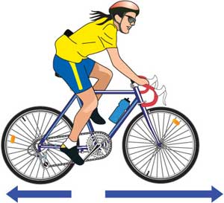

Which of the following describes the effect of the pair of forces on the bike?

(a) The bike will accelerate forward.
(b) The bike will change its direction of motion.
(c) The bike will remain stationary.
(d) The bike will decelerate.

16. What is the acceleration of a car if it increases its velocity from 5.0 m/s to 15.0 m/s in
4.0 seconds?

(a) 2.5 m/s
(b) 15 m/s²
(c) 2.5 m/s²
(d) 5.2 m/s²

17. A class is studying Newton’s three laws. The teacher asks a student wearing rollerblades to face the wall and push against it. The student moves backwards away from the wall. Which is the best explanation for her movement?

(a) Her action of pushing resulted in a reaction force by the wall, in the opposite direction to her push.
(b) She used her feet to push herself away from the wall.
(c) The push is a force and causes her to accelerate.
(d) The inertia of the student is responsible for her acceleration.

18. Which of the following statements is correct?

(a) A car at rest has at least two forces acting on it.
(b) A car at rest has no forces acting on it.
(c) When you take your foot off the car’s accelerator, the car slows down because there are no more forces acting on it.
(d) When you brake in a car that is rolling down a hill, the car stops because all of the forces add up to zero.

Part 2: Short Answer

1. Decide whether each of the following statements is true (T) or false (F). (4 marks)

(a) Average speed is calculated by distance covered multiplied by the
time taken.

(b) 40.0 km/h = 144 m/s

(c) When a car accelerates quickly, you move forward in your seat.

(d) A negative acceleration occurs when a car goes backwards.

2. The map below shows Broome and Alice Springs. Use the map and its scale to work out the following.

(a) The distance between Broome Airport and Alice Springs airport. (1 mark)

(b) The displacement between the two airports. (HINT: Don't forget to include a bearing.)
(3 marks)

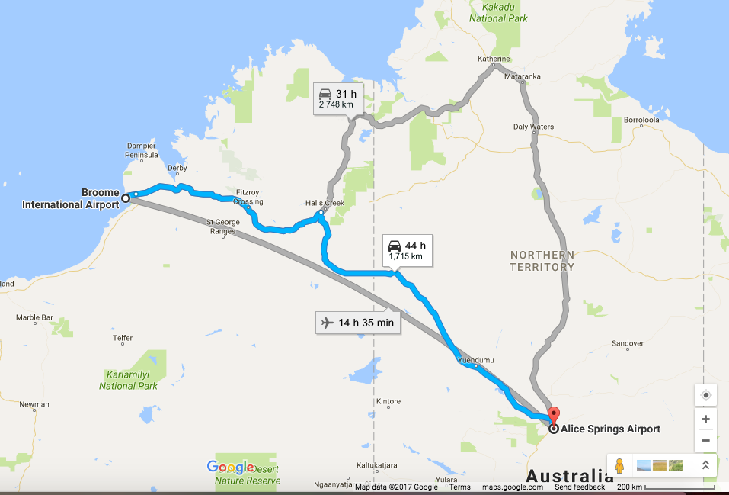

3. Complete the following table on speed calculations. Make sure you include the appropriate units for each quantity.
(3 marks)

Distance travelled | Time taken | Average speed
490 m | 35 s
 | 12 s | 23 m/s
121 m |  | 11 m/s

4. Explain why it is dangerous to have large parcels or sharp objects loose in the back of a moving car. (2 marks)

5. Describe how a front air bag protects the driver of a car that has stopped suddenly as a result of a collision. (2 marks)

6. Describe the motion of a ball placed on the middle of the back seat of a car in the following situations.

(a) The car brakes suddenly. (1 mark)

(b) The car turns right. (1 mark)

(c) The car accelerates. (1 mark)

7. A dragster accelerates from rest at 14.5 m/s² for 6.90 s during a race. What is the velocity of the vehicle after this time? (Set your working out clearly.) (3 marks)

8. Complete the following table on force and acceleration. (3 marks)

Force | Mass | Acceleration
 | 1200 kg | 5 m/s²
150 N | 25 kg
60 N |  | 2.5 m/s²

9. The Space Shuttle lands at 270 km/h (75 m/s) and immediately pops a drag chute to assist its brakes to stop the vehicle. Assume that the braking forces are uniform for this motion.
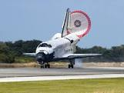

(a) If it takes 15 s to stop, calculate the deceleration experienced by the crew. (3 marks)

(b) If the mass of the Shuttle is 34,500 kg, what is the average force exerted by the brakes and the chute?
(If you couldn't find an answer for part (a), use deceleration = - 6.0 m/s².)
(3 marks)

10. An object has a mass of 6.0 kg.

(a) What is its weight on Earth? (2 marks)

(b) Would the object weigh more or less on the Moon? Explain your answer.
(2 marks)

(c) What is its mass on the Moon? (1 mark)

